22.

**TWO BIT HALF SUBTRACTOR**

**EXP.NO: 22**

**AIM:**

To design and implement the t

wo bit half

subtractor

using

Logisim

simulator.

**PROCEDURE:**

1)

Pick and place the necessary

gates.

2)

Insert 2 inputs into the canvas.

3)

Connect the inputs to the OR gate, AND gate and

NOT gate.

4)

Insert 2 outputs into the canvas.

5)

Make the connections using the connecting wires.

6)

Verify the truth table.

**TRUTH TABLE:**

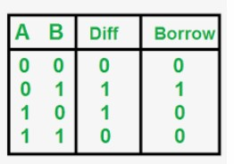

Diff=A'B+AB'

Borrow = A'B

Logical Diagram:

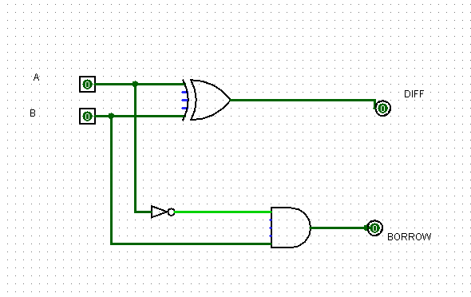

|  |  |  |  |  |
| --- | --- | --- | --- | --- |
| Half | Subtractor | using | NAND | Gates: |

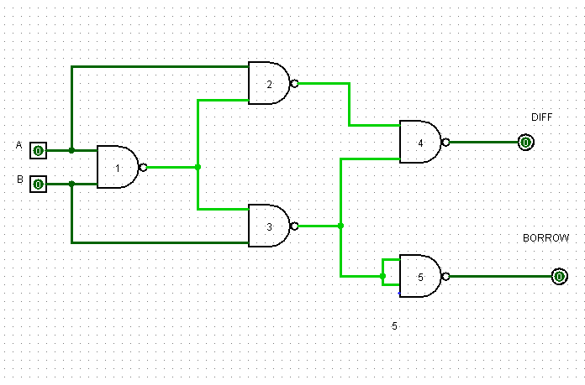

|  |  |  |
| --- | --- | --- |
| Half | Subtractor | using NOR Gates: |

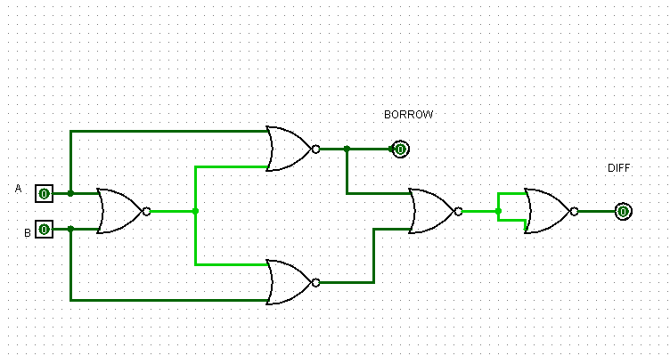

# OUTPUT

|  |  |  |  |  |  |
| --- | --- | --- | --- | --- | --- |
| **RESULT:** | | Thus 2-bit half | | subtractor | has been designed and implemented successfully using |
| logisim | simulator. | |  | | |